|  |  |  |  |
| --- | --- | --- | --- |
| **l GOOD COUNSEL COLLEGE** | |  |  |
| **BUSINESS EDUCATION DEPARTMENT** | |
| STUDENT NAME: | James Macgillivray |
| TEACHER: | SNGT |

|  |  |  |  |
| --- | --- | --- | --- |
| **ASSESSMENT CONDITIONS** | |  | **ECONOMICS AND BUSINESS**  **Business Plan** |
| **Date Received:** |  |  |
| **Date Due:** |  |  |

|  |  |  |  |  |  |  |  |
| --- | --- | --- | --- | --- | --- | --- | --- |
| **Assessment Instructions:**   1. Use Calibri - Size 12 2. Use 1.5 Line Spacing | | | | | |  | **Year 9**  **SEMESTER 1, 2021**  **Instrument No.**  **2**  **TOPIC ASSESSED:**  **The Business Environment –**  **Business Ventures**  **CRITERIA ASSESSED:**   * **Knowledge & Understanding** * **Skills** |
| **s** | | | | | |  |
| **SUMMARY OF RESULTS** | | | | | |
| **CRITERIA ASSESSED** | **STANDARD** | | | | |
| **A** | **B** | **C** | **D** | **E** |
| Knowledge & Understanding |  |  |  |  |  |
| Skills |  |  |  |  |  |

|  |  |  |  |  |  |
| --- | --- | --- | --- | --- | --- |
| **Dimension** | **A** | **B** | **C** | **D** | **E** |
| **The student work has the following characteristics** | **The student work has the following characteristics** | **The student work has the following characteristics** | **The student work has the following characteristics** | **The student work has the following characteristics** |
| **Knowledge and understanding** | * thorough explanation of how business seeks to create a competitive advantage, including through innovation | * detailed explanation of how business seeks to create a competitive advantage, including through innovation | * explanation of how business seeks to create a competitive advantage, including through innovation | * description of how business seeks to create a competitive advantage, including through innovation | * statements about: * creating a competitive advantage, including through innovation |
|  | | | **OVERALL STANDARD** |  |
| **Skills** | * gathering and discerning analysis of relevant data (SURVEYS) and information from different sources to: * effectively answer questions * identify and explain trends * discerning evaluation of the strategies that may be used | * gathering and informed analysis of relevant data (SURVEYS) and information from different sources to: * effectively answer questions * identify and describe trends * informed evaluation of the strategies that may be used | * gathering and analysis of relevant data (SURVEYS) and information from different sources to: * answer questions * identify trends * evaluation of the strategies that may be used | * gathering and use of data (SURVEYS) and information to: * answer aspects of questions and * explanation of the strategies that may be used | * use of aspects of data (SURVEYS) and information to: * answer aspects of questions * strategies that may be used |
| * discerning analysis of the effects of economic and business decisions and the potential consequences of alternative actions | * informed analysis of the effects of economic and business decisions and the potential consequences of alternative actions | * analysis of the effects of economic and business decisions and the potential consequences of alternative actions | * description of the effects of economic and business decisions and aspects of the potential consequences of alternative actions | * statements about potential consequences of economics and business alternative actions |
| * discerning use and coherent control of mode, genre and language conventions to suit intended audience and purpose. | * effective use of mode, genre and language conventions to suit intended audience and purpose. | * use of mode, genre and language conventions to suit audience and purpose. | * use of mode and language conventions to suit aspects of the purpose | * communication of aspects of information. |
| **OVERALL STANDARD** | | | | |  |

Business Plan

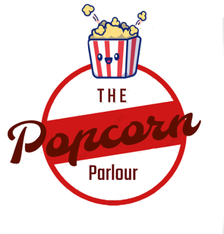

3..2..1..POP!

|  |  |
| --- | --- |
| Business Name: | The Popcorn Parlour |
| Due Date: | 15/6/21 |
| Author: | James Macgillivray |

# Table of Contents

Table of Contents 5

Executive Summary 6

Business Profile 6

Market Analysis 8

The Marketing Plan 8

The Operations Plan 9

5.0 The Organisational (Human Resource) Plan 10

The Financial Plan 11

Associated Information 12

# Executive Summary

**The business and the product**

The business, The Popcorn Parlour, is a small business which sells various flavoured popcorn. The Popcorn Parlour logo shows a red circular shape with text and a popcorn logo at the top of it. The colour red was chosen as it is the stereotypical popcorn colour with the other, white being in the background of the logo. The slogan for the business is 3, 2 ,1 POP!. The name of the business was created due to its alliteration and because it has a name that rolls off the tongue. The structure of the business is a partnership between 5 members of the Year Nine Business class of Good Counsel College, Innisfail.

## Business Profile

**1.1 The Business concept**

The Popcorn Parlour is based in the hospitality industry as it serves as a supply of flavoured popcorn for the students of GCC. The idea of popcorn is quite good as a business endeavour as the product being sold is not very costly and not very difficult to produce on a large scale.

* 1. **Mission Statement**

The Mission statement of the Popcorn Parlour is to supply our customers with quality popcorn.

* 1. **SWOT Analysis**

|  |  |
| --- | --- |
| Strengths | Intelligence, adaptability to fit the current situation and persistence |
| Weaknesses | Creativity in product and graphic design. Disagreements on how the business is run |
| Opportunities | Generating wealth through sales and developing social skills with people. Selling popcorn during *Grade of Origin*. Obtaining preorders |
| Threats | Food poisoning caused by lack of hygiene, competitors taking sales, and dislike of the product due to lack of quality. |

* 1. **Competitive Analysis**

The competitors to The Popcorn Parlour will be the school tuckshop and the other students’ business ventures, as they will be in the same market of supplying students with food. The price of food at the school tuckshop is quite competitive compared with the prices we are selling popcorn. The cost of one brown paper bag of popcorn is the same as a pastie or 2 chicken strips. The other students’ businesses are in slightly different markets as they are providing sweet food, not savoury. The tuckshop, the main competitor, could create an issue where students decide their money is better spent on regular tuckshop than our popcorn. This will be at least partly be remedied by the fact that our product is new and is limited ,creating a sense of missing out if they do not purchase any of the product.

## Market Analysis

**2.1 The Market Size and Trends**

The Target market for the business The Popcorn Parlour is the average tuckshop user who is willing to spend money on their daily lunch and is interested in purchasing something different.

**2.2 The Target Market**

The specific target market person will be anyone with money, is interested in purchasing popcorn and is in the lower grades. The first two are self-explanatory but the last factor is due to the Popcorn Palour selling near the primary seats for the Junior college members. The amount of customers we expect to sell to will be anywhere between 70 and 120 although those could be return customers.

## The Marketing Plan

**3.1 The Marketing Strategies**

The Popcorn Parlour plans to enter the market on June 7 and every Monday after that until the end of the term. On June 7 we plan to hold a stall in Mary’s Place during first break, sell in the tuckshop during second break, and supply the preorders to the customers on the day.

**3.2 The Marketing mix**

**Product**

The product, being popcorn, is presented in a brown paper bag wit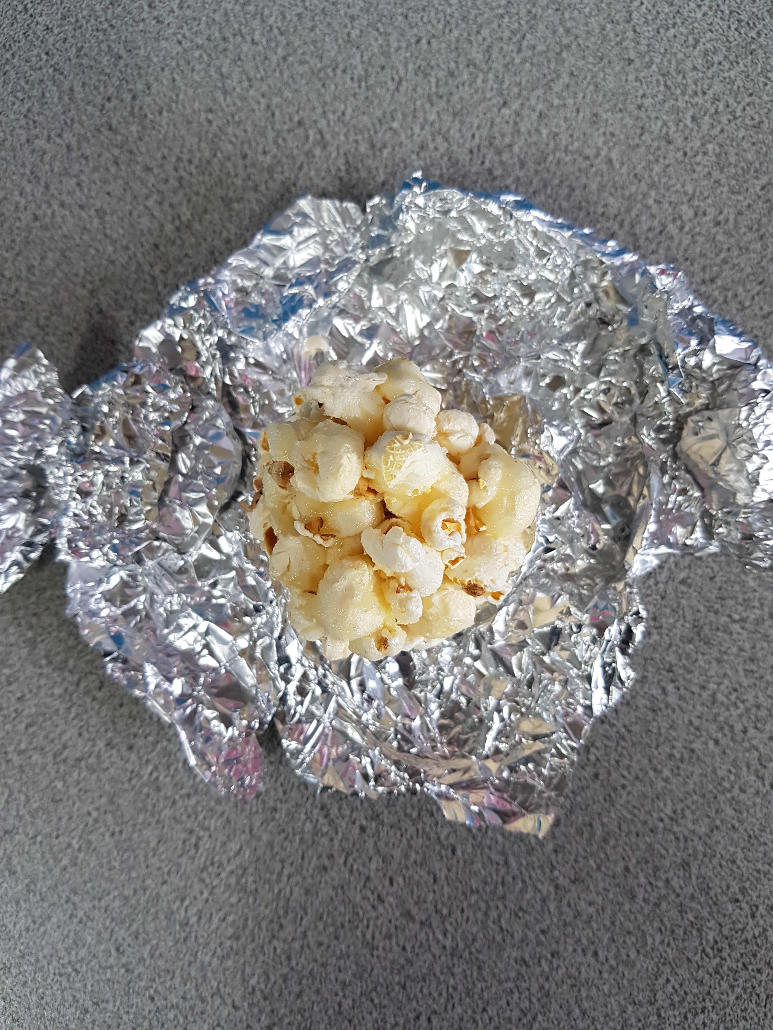h a label of the product that was preordered listing ingredients. As the brown paper bag is not big enough for the “Jumbo” size we plan to use a larger popcorn box to store the 2L of popcorn for it.

Popcorn Made for Prototype

**Place**

The popcorn will be distributed in 3 ways, from Mary’s place during first lunch, the school tuckshop during second lunch and distributing the preorders during breaks or homeroom, depending on whether we can find the customers.

**Price**

The prices of The Popcorn Parlour target the the average College consumer as the prices are similar enough to the tuckshop that anyone who would have purchased from the tuckshop have now the option to purchase from The Popcorn Parlour. The prices for The Popcorn Parlour are $3.00 for plain and cinnamon, $3.50 for caramel and $8.00 for the jumbo size. The Popcorn Parlour have the cheapest product of the other business ventures making the price very competitive.

**Promotion**

The business is being promoted through posters around the school advertising our presence and the prices of the popcorn. The business will also be promoted by a speech to the school during assembly the week before the first sales.

## The Operations Plan

* 1. **The Production Facilities**

We will source our supplies from the local supermarket at the most cost effective price. The costs for the popcorn itself are quite small which means the total cost per packet is less. We will make the popcorn in a small production line with two people making the popcorn and three packing the popcorn. We will wash our hands regularly and avoid touching hot surfaces.

* 1. **The production logistics**

The popcorn will be distributed through three ways. The first way is setting up a table in Mary’s place during first break on Mondays, targeting the Year 7s and 8s who sit there.

The second way is to set up in the tuckshop to target the students who buy tuckshop and the Year 9s and 10s who sit there.

The third way is to give popcorn to the homeroom of students who did not pick up their preorders.

We will be required to ask the tuckshop ladies for permission to sell there. Issues could include underestimating the amount of time required to cook the popcorn. This will be remedied by not creating a fixed timetable and allowing time to cook for as long as needed. The strategies used to save costs will be to buy ingredients at the lowest price per unit. Since a registered kitchen is required we will cook in the leader’s relative’s kitchen. Basic cooking equipment is required such as saucepans, stirring utensils, measuring equipment and large containers.

Where will you source your supplies from?

* 1. **The Production Costs**

The cost of one caramel popcorn is quite small and approximately 50c per bag. The other flavours are significantly less. The quality control measures for the product include making sure every bag has the same amount of popcorn, removing any burnt popcorn and keeping the popcorn in an airtight container to prevent staleness.

## 5.0 The Organisational (Human Resource) Plan

* 1. **The Key Personnel and Responsibilities**

Organisational Chart

In the business the duties include - James and Leo for graphic design, Lachlan for organising general business practises and meetings, Henry for financing, and Noah for interacting with customers. As a business we shared the work of making, selling and distributing the popcorn.

* 1. **The External advisors**

The advisors of the business include Mrs Snodgrass and the business members’ parents for assisting with various recipes and cooking advice. This greatly helped as they have given us the method and recipe for the caramel popcorn.

## The Financial Plan

* 1. **The Financial forecasts and analysis**

The establishment costs for the business includes the first batch of popcorn for the business’ opening and the expenses for the ongoing popcorn which is approximately $50. The ongoing expenses should be less than $50 per day as we expect to have less business than the first day. We also do not have to purchase the utensils for cooking. The Popcorn Parlour expects to make $250 to provide $50 to each partner. This will require sales to persist through the 3 selling dates.

* 1. **The Sources and uses of Finance**

The initial source of money to fund the business will come from money from the preorders to purchase the initial ingredients and equipment. If this money is not enough we will have to use some or all of the $20 float provided to us by the school.

## Associated Information

**7.1 Appendixes**

**A Market Survey results**

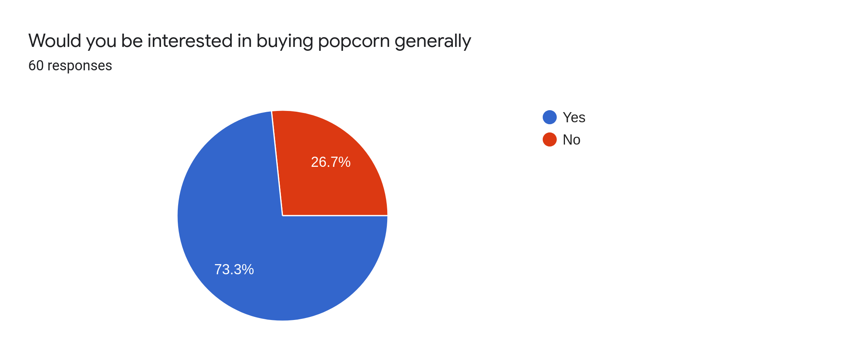

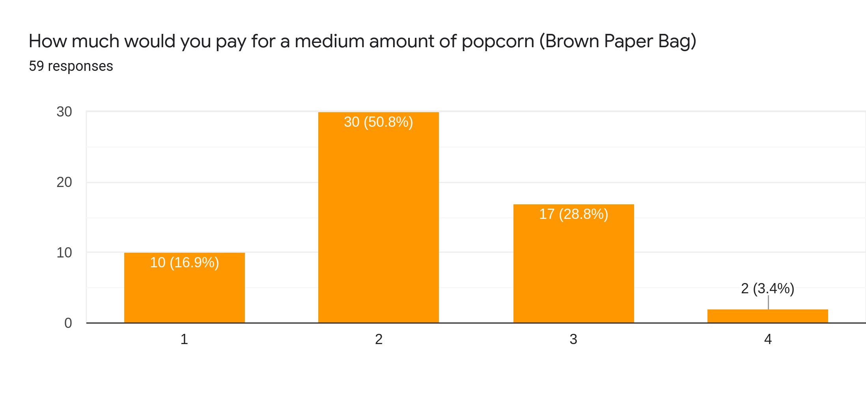

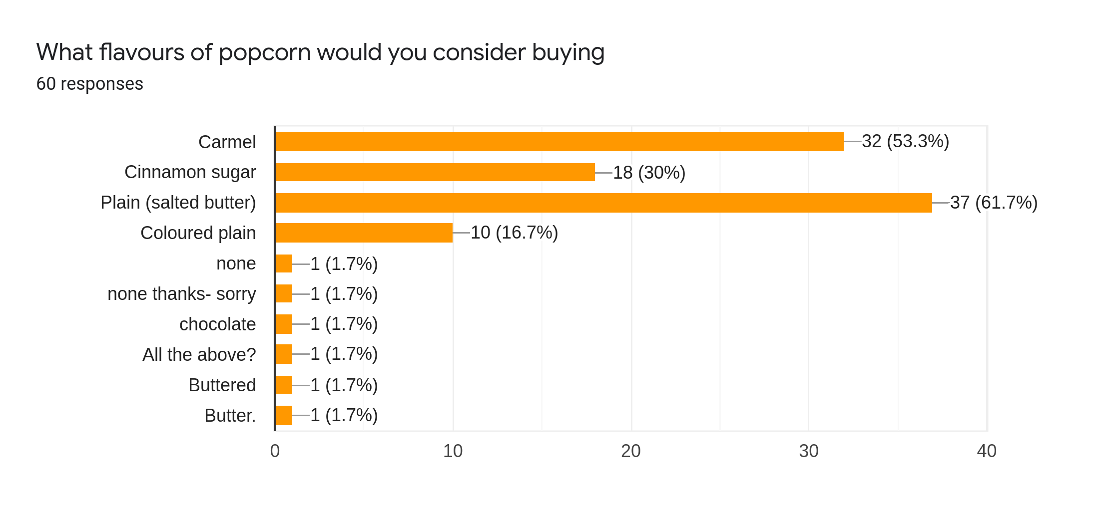

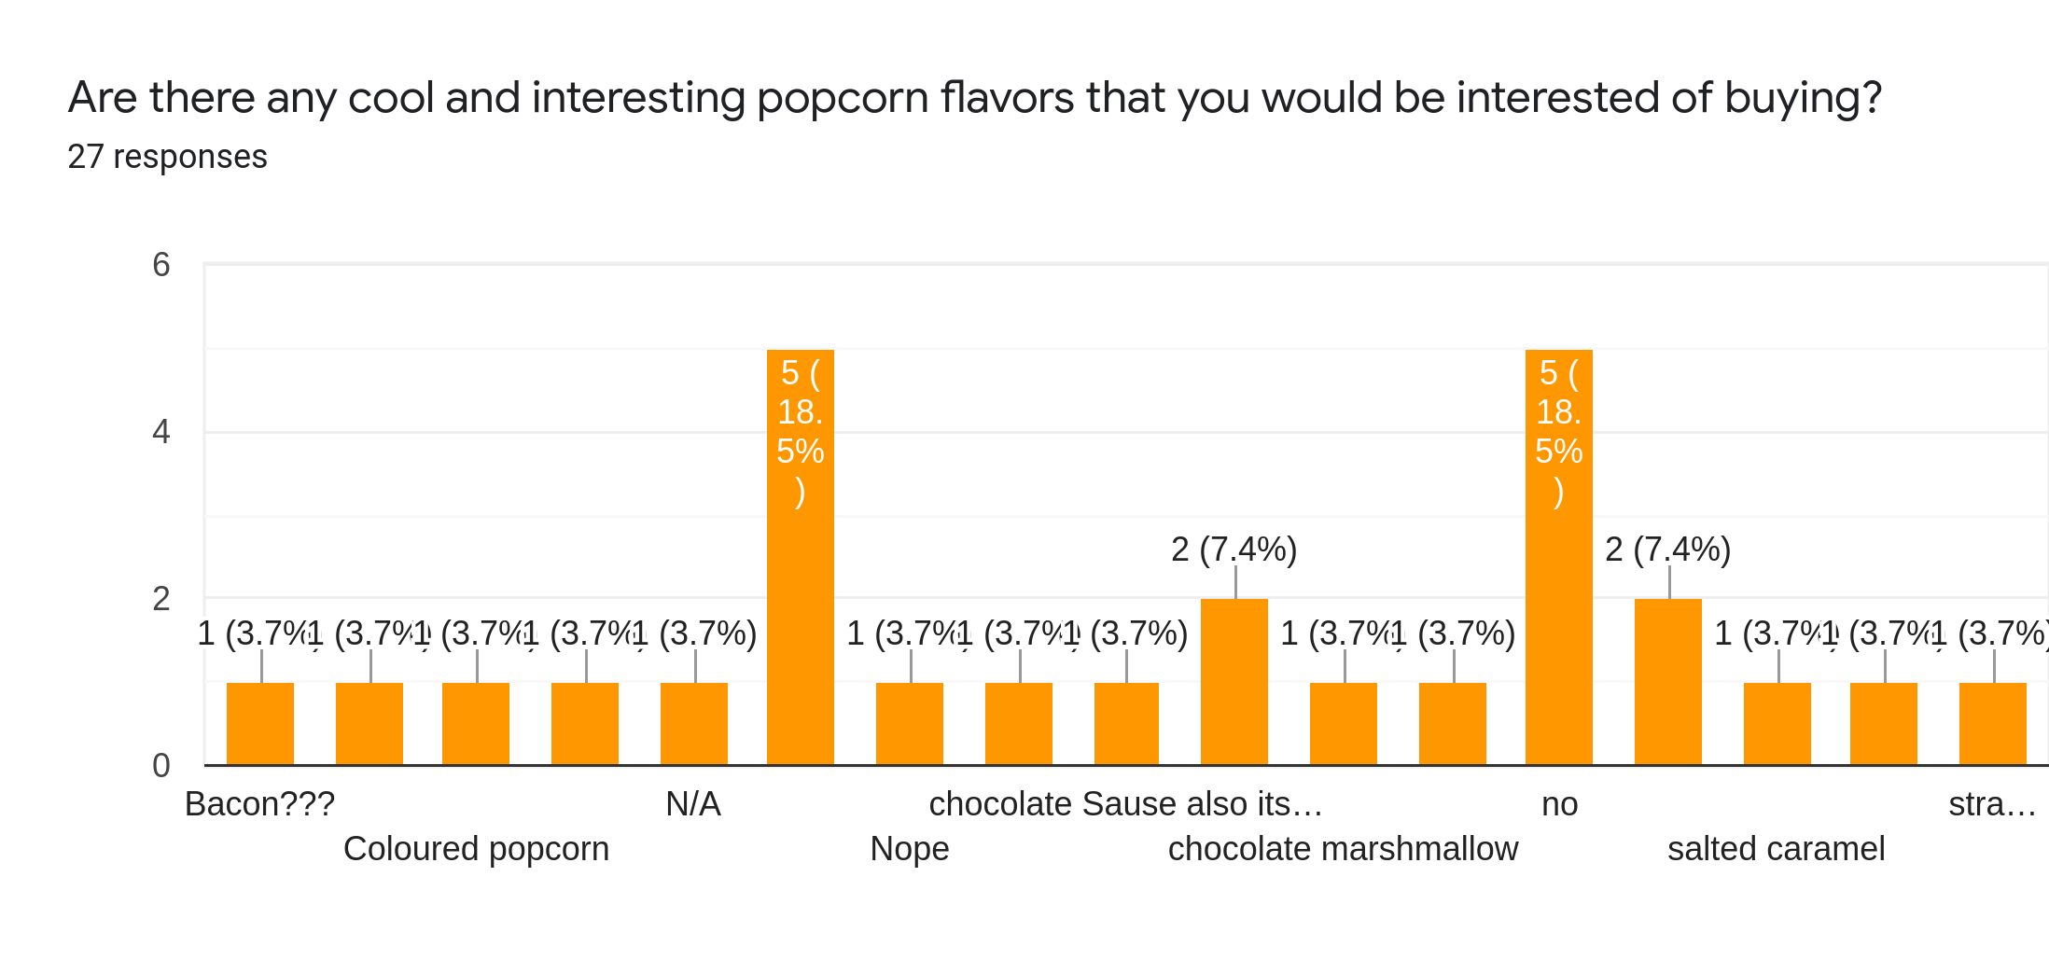

**B Ingredients List**

Buttered:

Kernels

Extra mild olive oil

Butter

Salt

Cinnamon:

Kernels

Extra mild olive oil

Cinnamon

Sugar

Caramel:

Kernels

Extra mild olive oil

Butter

Sugar

Honey

**C Poster**

